AD131
PHOTODETECTOR
MODULE

User Manual

Document # 1092109

August 2006

Introduction

Mission Statement
Our mission is to provide our customers with reliable products, on time, and at a fair price. We are continually striving to maintain the highest standards, by assuring defect-free products and by providing prompt and courteous customer service.
The staff at Spectral Products will be happy to answer any questions about our products and our services. For immediate assistance, please contact the Spectral Products Group directly at (505) 343-9700, by fax (505) 343-9705, or by e-mail at sales@spectralproducts.com

Warranty
This product is warranted to be free of defects in materials and workmanship for one year from date of purchase.
This manual and the software it describes are provided free of charge as a service to the customer. The software is intended to be used as a tool for development and as an example of one possible method of code implementation. It is not intended to be a “user application.”
Any software associated with this product is provided “as is” with no warranty, expressed or implied. While it is Spectral Products’ intent to provide error-free development tools, no guarantee is made regarding either the accuracy or usefulness of this material.
Failures or damages resulting from lack of operator attention to proper procedures, failure to follow operating instructions, unauthorized modifications, and natural disasters are not covered under this warranty.
SpectralProducts reserves the right, without prior or further notice, to make changes to any of its products described or referred to herein to improve reliability, function, or design.
Spectral Products accepts no liability for incidental or consequential damages arising from the use of this software.
Spectral Products does not recommend the use of its components or software products in life support applications wherein a malfunction or failure of the product may directly threaten life or result in injury.
Spectral Products does not recommend that this product be used on the same power line as other equipment with high current draw requirements.

Copyrights
Spectral Products maintains the copyright on this material, but grants the customer rights to use or to modify the software described herein without obtaining Spectral Products permission and without the requirement to reference Spectral Products as the source of the material.

TABLE of contents
1. 1. GENERAL 3
2. INSTALLATION 3
2.1 MECHANICAL CONNECTIONS 3
2.2 SUPPORT SOFTWARE 3
3. THEORY OF OPERATION 4
3.1 CHARGE INTEGRATION 4
3.2 AD131 INTERNAL COMMUNICATION 4
3.3 SENSOR HEADS 5
3.3.1 TE-COOLED SENSOR HEADS (OPTIONAL) 7
3.4 DATA TRANSMISSION 9
3.5 RS232 COMMUNICATION 9
4. COMMANDS 10
4.1 D - Retrieve a data measurement. 10
4.2 L - Set the integration variable (gain). 10
4.3 G - Read back the integration variable (gain). 10
4.4 X - Extension to gain range. [1 - 255] 11
4.5 P - Set the AD131 integration configuration. 11
4.6 R - Retrieve the present AD131 integration configuration. 11
4.7 A - Set the number of data retrievals to be averaged. 13
4.8 S - Sensor head selection; Si / Other. 13
4.9 N - Null Function: enable / disable. 13
4.10 T - Test Current: enable / disable. 14
4.11 V - Firmware revision query. 14
4.12 C - Si/Ge or PbS/PbSe Sensor. 14
4.13 TEC COMMANDS 15
4.13.1 1- Power 15
4.13.2 2-Cooler 15
4.13.3 3-Temperature 15
4.13.4 4-Stages 15
5. DIAGNOSTICS 16

1. GENERAL

The AD131 detector module supersedes the discontinued AD130 detector module. The AD131 is designed by Spectral Products to operate with any of Spectral Products’ monochromators. The AD131 module does not have the sensitivity of a photomultiplier tube, and is therefore not appropriate for some applications.

INSTALLATION

MECHANICAL CONNECTIONS

The AD131 module connects with an RS232 serial cable to any functioning serial port on the user’s PC.
The power supply, (P/N 6-1065) provides all of the power requirements for the module (±12V, +5V). The red LED located between the connectors will be constantly on during normal operation. If the LED is flashing, the unit has probably been inadvertently strapped to the diagnostic mode, in which case see the DIAGNOSTICS section of the manual to reconfigure for normal operation. An unlit LED signifies the absence of power, command scramble at power up, or the unit being strapped for the diagnostic mode, with strapping of B and F. Try cycling the power off then on; if this does not restore the LED to constant ‘ON’ condition, see the diagnostics section for further details.

SUPPORT SOFTWARE
Support software is included with the AD131 when it ships. Please read the document file included on the software disk. Software including for the AD131 LabVIEW© drivers for this product are available from Spectral Products’ website at www.spectralproducts.com.

THEORY OF OPERATION

CHARGE INTEGRATION
At the heart of the AD131 is a charge digitizing A/D converter with 20 bit resolution. For each conversion, the input signal current is collected on the internal integration capacitor. The integration period is user programmable, and constitutes the only signal gain mechanism. The AD131 is not an ‘event capture’ device; for all practical purposes the optical signal must be constant for accurate measurements.

After a short signal acquisition period (k), a digital filter over-samples the tracking logic’s output at the start and end of each integration period, to produce two over-sampled data points. Correlated double sampling (CDS) is performed by subtracting these two points, eliminating integration cycle dependent errors. The number of over-samples, as well as the acquisition period, is user programmable. The best response is obtained from the A/D converter when it is operated in continuous integration mode. In order to take advantage of this operating mode, the A/D converter is run in a ‘pseudo-continuous’ mode; continuous mode is begun, and the third measurement (for stability purposes) is retained, and sent to the host.

NOTE: erroneous readings will occur if the user defined integration period is shorter than the time required for acquiring the over-sample measurements. Relevance: if using gain (G) of less than 7 (the default value), reduce the default over-sample value (using the sub-command M, within P command) from 128 to a lesser value.

With the extended gain (X) set to one, there is a base integration period of 87.5 μsec, and an additional integration time of 8μsec for each unit of gain (G). The over-sampling (m) requires 0.5 μsec per over-sample unit, plus 0.5 μsec for each unit of acquisition time control (k). The default parameters of m = 128 and k = 16 produce a minimum integration period of [(128*2) + 16] [0.5μsec] = 136μsec. For error free results with these values of k and m, the integration period must be larger than 136μsec. This requires an integration period greater than 136μsec. A value for G of 6 results in 135.5μsec [87.5μsec + (6 * 8μsec) = 135.5μsec], while a G of 7 results in 143.5μsec [87.5μsec + (7 * 8μsec) = 143.5μsec]. For m = 128 and k = 16, the gain, G, must be at least 7.

AD131 INTERNAL COMMUNICATION
Within the AD131, the microcontroller unit (MCU) is constantly ‘polling’, or looking for the next command on the RS232 line. Once a command is received, the CTS communication line is de-asserted, telling the host not to send any further commands. The received command is processed, and acted upon. For most commands, further communication is required between the MCU and host, such as the return of the present value of a programmable parameter. This information is sent to the host, and the CTS line is re-enabled to allow the host to send a response to the returned data. Once this response is received by the MCU, the CTS line is again disabled until the command has been completely processed.

The communication between the MCU and the data acquisition IC is handled serially. During the power-up cycle, default parameters are sent to this IC. The user may subsequently modify these parameters, but upon powering down and restarting, the default parameters will be reloaded.

SENSOR HEADS
There are several sensor head configurations available for the AD131. The devices and their Spectral Products part numbers, along with the pin out, are shown below.

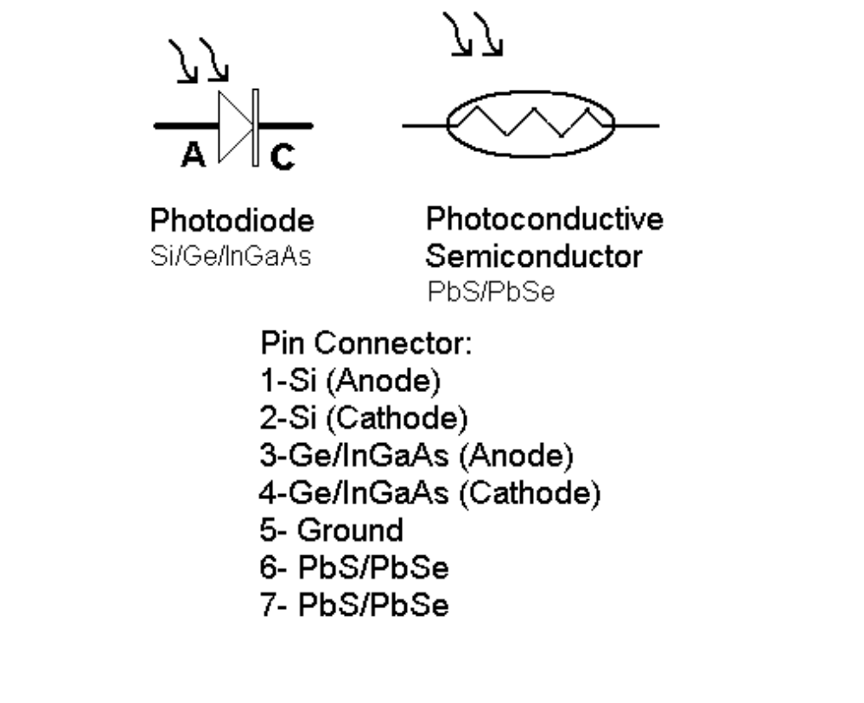
Pin out (TE Cooled – Optional)
8 | Anode (reserved)
9 | Cathode (reserved)
10 | N/C
11 | N/C
12 | Power
13 | Cooler
14 | Temperature
15 | Stages

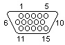

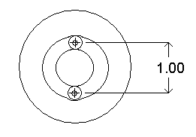

The AD428 sensor head is constructed of a Ge and Si device sandwiched one on top of the other; a Silicon photodiode that is IR transparent is overlaid upon the IR sensing Germanium detector. The AD431 is a sandwich detector with Si on top and InGaAs on the bottom. Responsivity and active area are both less for the sandwich detectors (AD428 & AD431), as can be seen in the following table:

Sensor Head | Responsivity  R_{λp}  (mA/W @ λ_{p}) | Photo  Sensitivity  S(λ=λp)  (V/W ) | Active Area (mm) | Peak  Wavelength λ_{p}(nm) | Specific Detectivity  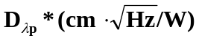
AD421 (Si) | 350 | N/A | 5.8 x 5.8 | 720 | 1.1 x 10¹³
AD426 (Ge) | 800 | N/A | Ø3.0 | 1550 | 1.0x10¹¹
AD428 (Si side) | 450 | N/A | 2.4 x 2.4 | 940 | 1.4 x 10¹³
AD428 (Ge side) | 500 | N/A | Ø2.0 | 1550 | 5.0 x 10¹⁰
AD430 (InGaAs) | 950 | N/A | Ø3.0 | 1550 | 5.0 x 10¹²
AD431 (Si side) | 450 | N/A | 2.4 x 2.4 | 940 | 1.4 x 10¹³
AD431 (InGaAs side) | 550 | N/A | Ø1.0 | 1550 | 3.5 x 10¹²
AD427 (PbS) | N/A | 1 x 10⁵ | 1x5 | 2200 | 1 x 10¹¹
AD429 (PbSe) | N/A | 5 x 10² | 3x3 | 3800 | 1 x 10⁹

The responsivity tells what photocurrent will be generated by the sensor for a given optical power level, but does not address the issue of thermal detector noise. The specific detectivity D*, on the other hand, is a measure of the intrinsic detector signal to noise ratio. Hence, D* is higher for a better detector. For example, the Si side of the AD428 Si/Ge sensor head has a lower responsivity than the Ge side, but it has a far higher D*. This means that although the signal from the Si side will be smaller than that from the Ge side, its noise level will be far lower. The signal to noise ratio will be much higher for the Si side than for the Ge side.

TE-COOLED SENSOR HEADS (OPTIONAL)

TE-Cooled sensors available (one stage):

 |  | Responsivity  R_{λp}  (mA/W @ λ_{p}) | Photo  Sensitivity  S(λ=λp)  (V/W ) | Active Area (mm) | Peak  Wavelength λ_{p}(nm) | Specific Detectivity
AD430-C (InGaAs) |  | 950 | N/A | Ø3.0 | 1550 | 2.0 x 10¹³
AD427-C (PbS) |  | N/A | 9 x 10⁴ | 4x5 | 2200 | 1.0 x 10¹¹
AD429-C (PbSe) |  | N/A | 1 x 10³ | 3x3 | 3800 | 3 x 10⁹
AD431-C (Si/InGaAs) | Si | 450 | N/A | 2.4x2.4 | 940 | 1.4 x 10¹³
AD431-C (Si/InGaAs) | InGaAs | 550 | N/A | Ø1.0 | 1550 | 3.5 x 10¹²

Cooling the sensor requires using the AD131-TC temperature controller. A DB-9 Cable from the AD131-TC to the TE-Cooled sensor interfaces the AD131 Detector Module and the temperature controller. The AD131 Detector Module controls the power and temperature of the AD131-TC. Two LED’s indicate the status of the controller. The red LED indicates power and the white, which is a two color LED, indicates the temperature status. When the white LED turns red, it indicates temperature is setting on the sensor, and when the LED is green, it indicates temperature is set. The temperature for a one stage TE-Cooled sensor, when set, is -10ºC.

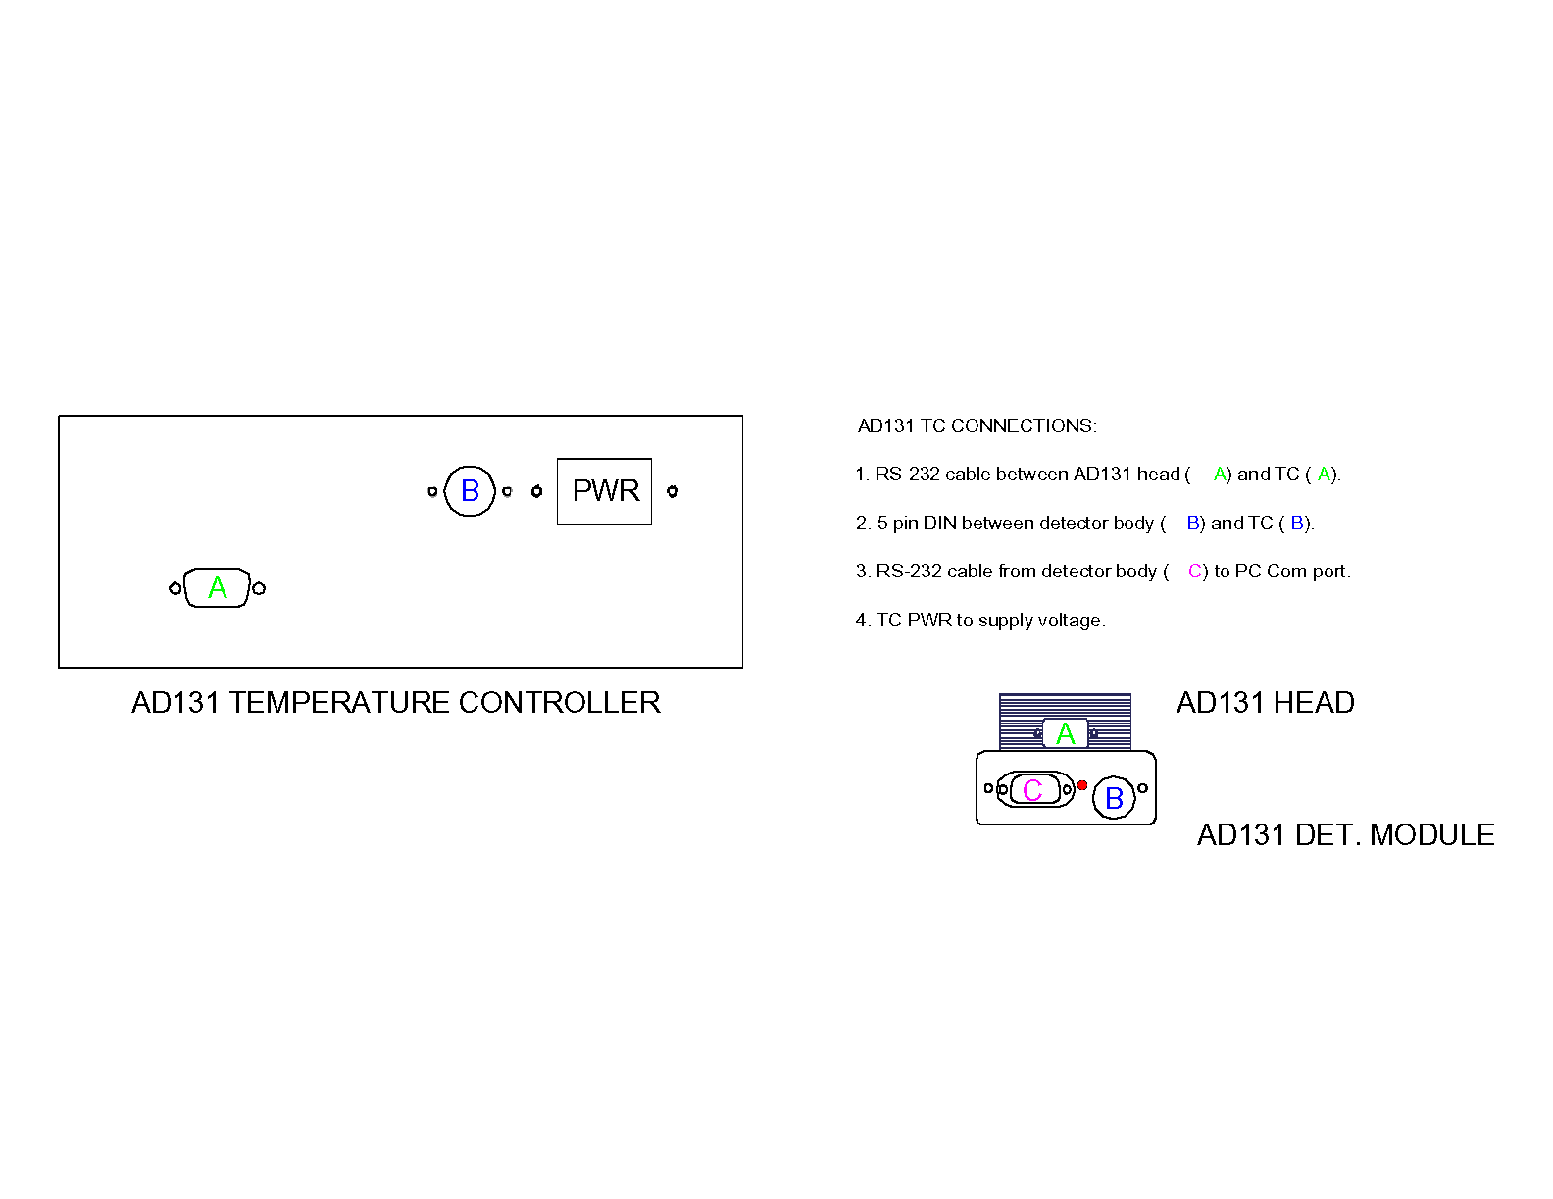

DATA TRANSMISSION
Commands are sent to the AD131 as single ASCII characters (see COMMANDS section for details). Numeric values are returned in binary.

One byte is sent back as the result of a query of the programmed integration variable (G). Eight bits are also sent back to the host after a command to change one of several other variables, detailing their current status. These are the L, A, S and N commands. See the COMMANDS section for more detail.

Two bytes are returned after a charge integration status query (R), or a charge integration status modify command (P).

Three bytes are returned from the AD131 as the result of a command requesting a data measurement. The data is sent to the host most-significant-byte first, with the first three most significant bits of the first byte being status bits. The status bits show the status of the internal test current (whether on or off), whether or not the NULL command is active, and if the averaged data has components that were either negative or larger than the measurable range(overflow/underflow).

DATA OUT: MSB - LSB

< FIRST BYTE > <SECOND BYTE > < THIRD BYTE >
1 1 1 1 1111 1111 1111 1111 1111
test null overflow sign data data data
current status underflow bit
status status (not used)

RS232 COMMUNICATION
The AD131 is configured as DCE equipment. Four signals comprise the RS232 communication:
TxD (Pin 3 of DB -9) an input from the controlling PC
RxD (Pin 2 of DB -9) an output to the controlling PC
RTS (Pin 7 of DB -9) an input from the controlling PC
CTS (Pin 8 of DB-9) an output to the controlling PC

The serial communication port of the AD131 uses a standard nonreturn-to-zero (NRZ) format of one start bit, eight data bits, and a stop bit. No parity bit is used. The baud rate is fixed at 9600, and is not variable. Please ensure that a standard RS232 cable is used, a null modem type will not work!

COMMANDS

syntax:
< > command sent from host
( ) value returned from AD131

D - Retrieve a data measurement.
< D > (0 - 1048575 + status bits)

Sending an ASCII “D” (hexadecimal 44) to the AD131 results in the return of a three byte data measurement plus status. See ‘Data Transmission’ subheading for more detail. With 20 bits of data available, the data range is 0 - 1048575 (2²⁰- 1). The first three bits of the Most Significant Byte are status bits. The fourth bit is the sign bit, which is unused in this unipolar application (any negative measured value is re-assigned the value of zero, although the ‘underflow’ status bit will be set). The last four bits of the Most Significant Byte are the four most significant bits of the twenty-bit data measurement.

L - Set the integration variable (gain).
< L > (1 - 255) < 1 - 255 >

Sending an ASCII “L” (hexadecimal 4C) to the AD131 results in the return of the present gain value (one byte, default value is seven). The AD131 expects this to be followed by a new gain value. If a new value is not sent to the AD131, it will interpret the next subsequent command received as the new gain value. Gain values are directly related to integration time; the higher the gain value, the longer the integration period, resulting in slower operation.

Erroneous readings are possible for low gain values if other setup parameters (oversamples per integration or acquisition cycles) are not modified from their default settings. See the theory section for more details.

G - Read back the integration variable (gain).
< G > ( 1-255)

Sending an ASCII “G” (hexadecimal 47) to the AD131 results in the return of the present gain value. This command provides a good check of device communication, since it requires a response from the AD131, but does not modify any of the AD131 operating parameters.

X - Extension to gain range. [1 - 255]
< X > (present extended gain value) < new extended gain value: 1 - 255 >

Sending an ASCII “X” (hexadecimal 58) to the AD131 results in the return of the present Extended Gain value. The AD131 then requires a new value be sent to complete this command cycle. The Extended Gain range is essentially a multiplication factor for the gain parameter (integration period) defined with the ‘L’ command. As such, it requires longer signal gathering time for larger values of gain. The Extended Gain field is set to a default value of 1.

P - Set the AD131 integration configuration.
< P > < K > < 1, 2, 3, 4 >
< M > < 1, 2, 4, 8, ...256 >

Sending an ASCII “P” (hexadecimal 50) to the AD131 initiates changing control parameters within the data acquisition chip of the AD131. After sending a ‘P’ to the AD131, a ‘K’ (hexadecimal 4B) or ‘M’ (hexadecimal 4D) must be sent to the detector to define which parameter will be changing. This is to be followed by the new value. If an unacceptable value is sent, the parameter will not be modified. K is the number of acquisition periods before the measurement begins, and M is the number of oversamples at the beginning and end of the measurement. See the ‘Theory of Operation’ section for more details.

The values of K or M sent to the AD131 are sent as binary values. Shifting of the bits to their proper location is handled within the AD131. For example, to send a K value of 3, ‘P’ and ‘K’ would be sent as strings, and ‘3’ would be sent as a numeric. The binary equivalent, 0000 0011 is sent.

R - Retrieve the present AD131 integration configuration.
< R > (multi-parameter two-byte value)

Sending an ASCII “R” (hexadecimal 52) to the AD131 prompts the AD131 to return two bytes of information that contain the settings for five parameters within the AD131. Only the first two parameters returned are modifiable by the user; they are the K and M sub-parameters accessed with the ‘P’ command. The first byte returned contains the K, and M parameters. The two most significant bits of the MSByte (bits 6 & 7) define the K parameter value. Bits 2 through 5 define the M parameter value.

Bits 0 and 1 of the MSByte, along with the values of the LSByte define parameters that are not modifiable by the user. The second byte must be read back upon the execution of the ‘R’ command, but the data is not relevant for user applications. The value of the second byte should always be hexadecimal 10.

The K parameter defines the number of 0.5μsec clock periods used at the beginning of a measurement cycle for signal acquisition, as well as enabling or disabling the Correlated Double Sampling (CDS) function. With a binary value of 00, the CDS function is disabled and no clock periods are used for signal acquisition. A binary value of 01 sets CDS on, but still uses no clock cycles for signal acquisition. Setting the K parameter to binary 10 sets CDS on and uses 15 clock cycles for signal acquisition. Setting the K value to binary 11 turns CDS on and provides 31 clock cycles of signal acquisition. The recommended value for K is binary 10, which is also the default value.

The M parameter sets the number of samples taken for oversampling the initial and final data points. These samples are then used with the CDS function to subtract the initial value from the final value. The use of CDS results in the elimination of various integration errors such as charge injection, kT/C, and internal offset errors. The larger the value of M, the greater the broadband noise reduction. The default value for M is 128. The allowable values for M and their corresponding binary codes are shown below:

CODE | Integrations Per Conversion
0000 | 1
0001 | 2
0010 | 4
0011 | 8
0100 | 16
0101 | 32
0110 | 64
0111 | 128
1xxx | 256

A - Set the number of data retrievals to be averaged.
< A > (present value: 1, 2, 4, 8, 16, 32, 64, 128) < new value: 1, 2, 4, 8, 16, 32, 64, 128 >

Sending an ASCII “A” (hexadecimal 41) to the AD131 prompts the AD131 to return the present one-byte Average value. The AD131 then waits for a new one-byte Average value. Only the above specified choices (binary equivalent) are allowable values for Average. If an invalid value is sent, the AD131 will complete this command sequence without modifying the Average value.
The Average field determines how many data measurements are summed and averaged before the result is forwarded to the host computer. When multiple signals are averaged, if any one of those signals triggers the overflow/underflow flag, the overflow/underflow status bit of the resulting averaged measurement will be set. The default value for Average is 1.

S - Sensor head selection; Si / Other.
< S > (currently selected sensor: 01/02) < new selection for sensor: 01/02 >

Sending an ASCII “S” (hexadecimal 53) to the AD131 prompts the AD131 to return the present one-byte sensor designator: 01 for silicon, 02 for other. The AD131 then waits for a new one-byte sensor selection value. This function switches the input of the charge digitizing circuitry. Selecting silicon places pins three and four of the sensor head as the active inputs, while selecting other places pins one and two as the active inputs. Unless a combination sensor head (AD228, AD231) is used, the mounted sensor head will physically have to be removed and replaced when switching between Si and other, unless an adapter has been constructed to allow mounting both sensor heads side-by-side. If an invalid choice is sent, the selected sensor does not change, and the sensor selection command is complete. The default setting for sensor head selection is silicon.

N - Null Function: enable / disable.
< N > < desired null function status: on = 01, off = 00 >

Sending an ASCII “N” (hexadecimal 4E) to the AD131, followed by the desired null function status (on = 01, off = 00) prompts the AD131 to enable or disable the null function as is appropriate. When the null function is enabled, the AD131 takes twenty-five measurements of data with the present AD131 settings, and stores the smallest of these twenty-five values for subsequent subtraction from all future measurements. Do not enable the null function until all setup parameters are set as desired for readings. The null function is used to eliminate large, constant background signals from the measurement, but it is not an ‘offset adjustment’ in that it does not cancel dark currents prior to signal amplification. The null function is default set to ‘off’. If an invalid setting is sent to the AD131, the null function status is not changed, and the null command is completed.

When the null function is ‘on’, the ‘null status bit’ in the returned three byte data measurement is set high. See ‘Data Transmission’ under the ‘Theory’ section of this manual for more details. Once enabled, the NULL function remains active until explicitly turned off, or power is cycled and all settings are reset to their default values.

T - Test Current: enable / disable.
< T > < desired status of test current: on / off; 01 / 00 >

Sending an ASCII “T” (hexadecimal 54) to the AD131, followed by the desired Test Current status (on = 01, off = 00) prompts the AD131 to enable or disable the AD131 internal test current. Sending an invalid value for the desired status causes the test current command to be completed without modifying the status of the Test Current function. The status of the Test Current function is reflected in one of the status bits of the three byte data measurement. See ‘Data Transmission’ under the ‘Theory’ section of this manual for more details. The internal test current is defaulted to the ‘off’ state.

The internal test current is approximately 100nA in value, but is not precise enough to use for calibration purposes (± 20nA). The value of the internal test current will be summed with any externally applied signal. Its function is primarily that of a diagnostic tool.

V - Firmware revision query.
< V > (installed revision of AD131 firmware)

Sending an ASCII “V” (hexadecimal 56) to the AD131 prompts the AD131 to return the one-byte ASCII representation of the installed AD131 firmware (ex.: hex 41 is returned for revision ‘A’ firmware).

C - Si/Ge or PbS/PbSe Sensor.
< C > (currently selected sensor: 01/02) < new selection for sensor: 01/02 >

Sending an ASCII “C” (hexadecimal 43) to the AD131 prompts the AD131 to return the present one-byte sensor designator: 01 for Si/Other, 02 for PbS/PbSe. The AD131 then waits for a new one-byte sensor selection value. This function switches the input of the charge digitizing circuitry. Selecting Si/Other places pins one and two or three and four, depending on the “S” status command, of the sensor head as the active inputs, while selecting PbS/PbSe places pins six and seven as the active inputs. Unless a combination sensor head (AD428, AD431) is used, the mounted sensor head will physically have to be removed and replaced when switching between Si, other, and PbS/PbSe, unless an adapter has been constructed to allow mounting sensor heads side-by-side. If an invalid choice is sent, the selected sensor does not change, and the sensor selection command is complete. The default setting for this selection is Si/Other.

TEC COMMANDS

The following commands are used only when controlling the (optional) AD131-TC Temperature Controller with a Thermoelectric Cooled sensor.

1- Power
<1> (present power status) <power: 01=off, 02= on>

Sending an ASCII “1” (hexadecimal 31) to the AD131 prompts the AD131 to return the present power status of the AD131-TC Temperature Controller: 01 for power off and 02 for power on. The AD131 then waits for a new one-byte value. If an invalid number is sent, the power status does not change, and the “Power” selection is complete. The default setting for this selection is off.

2-Cooler
<2> (present cooler setting) <Cooler: 01=off, 02= on>

Sending an ASCII “2” (hexadecimal 32) to the AD131 prompts the AD131 to return the present cooler setting of the AD131-TC Temperature Controller: 01 for cooler off and 02 for cooler on. The AD131 then waits for a new one-byte value. If an invalid number is sent, the cooler setting does not change, and the “Cooler” selection is complete. The default value for this selection is cooler off.

3-Temperature
<3> (present temperature setting)

Sending an ASCII “3” (hexadecimal 33) to the AD131 prompts the AD131 to return the present temperature setting of the AD131-TC Temperature Controller: 01 for temperature is set and 02 for temperature is not set. For a one stage thermoelectric cooled sensor, when set, is -10ºC.

4-Stages
<4> (number of stages)

Sending an ASCII “4” (hexadecimal 34) to the AD131 prompts the AD131 to return the present number of stages of the thermoelectric cooled sensor: 01 for two stage and 02 for single stage.

DIAGNOSTICS

The AD131 incorporates several limited diagnostics as a troubleshooting aid in the event of equipment failure. To make use of these diagnostics, the user must change the default internal strapping of the unit prior to the application of power. Standard precautions for handling static sensitive devices must be followed when the AD131 case is removed. Access to the straps is most easily affected by removing the endplate (two screws secure endplate) that has the cable connectors. With the endplate screws removed, the circuit board, sensor head, and cover plate should slide out easily. Before applying power to the unit, change strap A/B to B, and determine the desired strapping of the C/D and E/F straps (see below). Disconnect the RS232 cable at the host computer or detector if appropriate.

Factory setting for normal operation strapping is :A, C, and E.

Strap functions:

A/B - This strap is the primary diagnostics strap. For diagnostics to be enabled, strap A/B must be set to the B position prior to the application of power to the unit. If this strap is in the A position, then the C/D and E/F strapping options are irrelevant, and ignored by the AD131 detector.

Upon first powering up the unit in the diagnostic mode, the LED is illuminated for approximately three seconds to verify LED functionality. Next, the measurement acquisition IC within the AD131 is written to, and read from, to verify it’s basic functionality. If this step fails, the LED will flash a repeating single burst until communication with the measurement chip is successful. Failure at this step will probably require return of the unit to Spectral Products for repair. What happens following a successful write/read cycle is determined by the strapping of C/D.

C/D - The position of this strap determines whether the RS232 communications interface will be tested or not. In position C, the communications diagnostics are bypassed. In position D, the RS232 communication lines are exercised. To test the RS232 lines, the RS232 cable must be disconnected from the detector or the host computer. If the cable is disconnected at the host, the cable as well as the detector will be tested. When the cable is tested, the LED will flash twice for an RTS/CTS line failure until pins 7 and 8 of the 9-pin RS232 connector are shorted together (pins 4 and 5 of a 25 pin connector). Once these lines are successfully looped back, the LED will begin flashing three times, indicating a failure of the XMT/RCV lines, until pins 2 and 3 of the 9 pin RS232 connector (pins 2 and 3 of a 25 pin connector also) are successfully jumpered together.

If the test is successful when jumpered directly on the unit, but unsuccessful when jumpered at the end of the cable, continuity within the cable is suspect and should be verified separately. If the communications interface is not suspect, leaving strap C/D in the C position avoids the need to short the connector pins.

E/F - If this strap is set to the E position, a small test current (100nA) internal to the unit is then turned on and control is returned to the user. The internal test current being on is reflected in the status bits of the returned data. This internal test current may be subsequently turned off with the ‘T’ command, although the user is reminded to re-strap the unit to factory settings to avoid inadvertently entering the diagnostics mode after future power cycling. If strapped to the E position, the LED will revert to the constant ON status of normal operation.

If strapped to the F position, the internal test current is turned on, and data is acquired and sent to the RS232 interface continuously. The data is applied to the transmit pin even in the absence of a device connected to the interface. Although data is sent continuously to the RS232 output, communication with the host is not possible if in the diagnostic mode with the E/F strap set to F. If strapped to the F position, the LED is turned off once this Data Transmit test loop is entered, and remains off until the unit is re-strapped, and the power is cycled.

